
CENTRAL WEST EDUCATION DIVISION
2026 MALAWI SCHOOL CERTIFICATE OF EDUCATION MOCK EXAMINATION
PHYSICS
Subject Number: M164/II
Thursday, 31 March Time Allowed: 2 hours
10:00 am onwards

PAPER II
(40 marks)
PRACTICAL

Instructions
Question Number | Tick if answered | Do not write in these columns
1
2
3
4
TOTAL

- This paper contains 6 printed pages. Please check.

- Answer all the four questions in this paper.
- The maximum number of marks for each answer is indicated against each question.
- Write your answers in the spaces provided on the question paper.
- All working must be clearly shown
- Write your Examination number and School (Day/ODL) at the top of each page of your question paper.
- In the table provided on the page, tick against the question number you have answered

©2025 CWED MOCK Turnover

SECTION A (20 marks)
Answer all questions.
1. With the aid of a diagram, describe an experiment that can be used to determine the spring
constant of a spring using known masses, a ruler and clamp and clamp stand.

____________________________________________________________________________________________________________________________________________________________________________________________________________________________________________________________________________________________________________________________________________________________________________________________________________________________________________________________________________________________________________________________________________________________________________________________________________________________________________________________________________________________________________________________________________________________________________________________________________________________________________________________________________________________________________________________________________________________________________________________________________________________________________________________________________________________________________________________________________________________________________________________________________________________________________________________________________________________________________________________________________________________________________________________________________________________________________________________________________________________________________________________________________________ 10 marks

2. With the aid of a well labelled diagram describe an experiment that can be done to show that pressure of a fixed mass of gas is directly proportional to its absolute temperature when volume is constant.

____________________________________________________________________________________________________________________________________________________________________________________________________________________________________________________________________________________________________________________________________________________________________________________________________________________________________________________________________________________________________________________________________________________________________________________________________________________________________________________________________________________________________________________________________________________________________________________________________________________________________________________________________________________________________________________________________________________________________________________________________________________________________________________________________________________________________________________________________________________________________________________________________________________________________________________________________________________________________________________________________________________________________________________________________________________________________________________________________________________________________________________________________________________ 10 marks

SECTION B (20 marks)
3. You are provided with an insulate copper wire, soft iron nail, 4 cells in cell holders, switch, an ammeter, 4 connecting wires and 8 steel money clips.
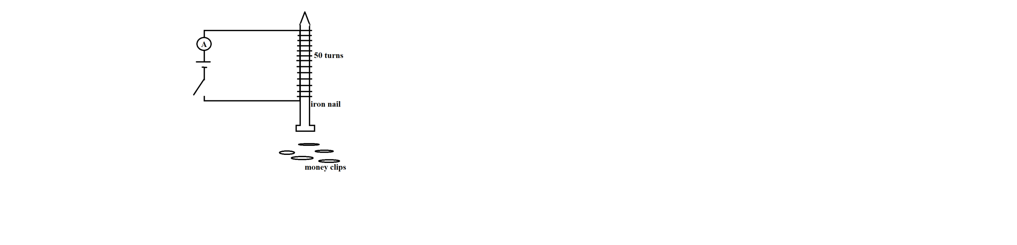
a. Set up the apparatus as shown in Figure 1 below:

Figure 1
b. Close the switch and record the ammeter reading in Table 1.
c. Place the money clips at the base of the nail one after another and record the maximum
number of money clips the electromagnet can keep attracted to it.
d. Repeat the experiment by increasing the number of cells as shown in Table 1.
Number of cells | Current (A) | Number of paper clips collected
1
2
3
4
4 marks
e. Which number of cells produces the strongest magnetic field?
__________________________________________________________________ 1 mark
f. From the results, how does current affect the strength of the electromagnet?
____________________________________________________________________________________________________________________________________________________________________________________________________________________ 2 marks
g. Explain why the number of pins collected increased when the number of cells increased
___________________________________________________________________________________________________________________________________________ 2 marks.
h. Suggest any one possible source of error in the experiment.
____________________________________________________________________________________________________________________________________________ 1 mark
4. You are provided with the following materials: a spiral spring, different masses (100g, 200g, 300g and 400g) a stop watch, clamp and clamp stand.
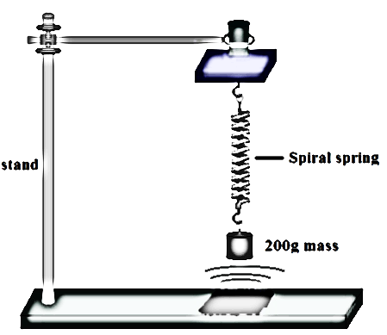

Figure 2
a. Set the materials as shown in figure 2 above.
b. Pull the mass downwards and allow it to oscillate freely up and down.
c. Note and record the time taken to complete 10 oscillations in the table of results. (table 2)
d. Calculate the frequency and fill the results in the frequency column.
e. Repeat steps (b), (c) and (d) using the 200g, 300g and 400g masses.
Mass (g) | Time taken for 10 oscillations (s) | Frequency (Hz)
100
200
300
400
4 marks
f. Plot the graph of frequency (Hz) against mass of the bob (g)

4 marks
g. Determine the relationship from the graph.
__________________________________________________________________ 1 mark
h. State any one factor that is kept constant during the experiment.
__________________________________________________________________ 1 mark

END OF QUESTION PAPER
There are 6 printed paged in this paper

